Template for Forms Documentation:

[Screen Shot]

Form Name:

Created By

Switchboard Location: example – Instructors add/remove…/add/remove Subjects/Log in History by Class

Purpose:

Template for Queries:

[Screen Shot]

Query Name:

Created by:

Used by: ex – specific officer or member

Parameters: Start Date, End Date

SQL Statement

Outputs To:

Purpose:

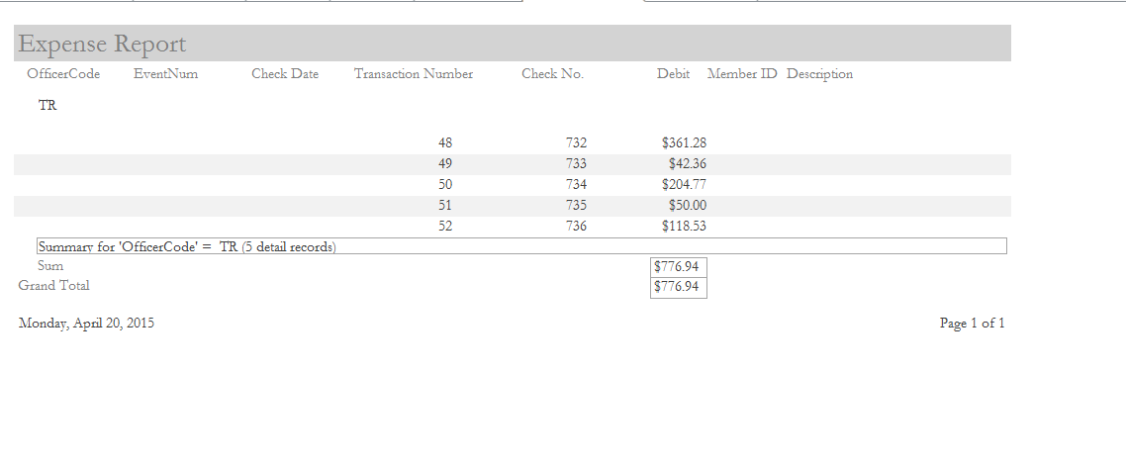

Report Name: Expense Report

Created by Donna Walker

Prepared for: Treasurer

Navigation Pane Location: ??

Query: Expense Query

Purpose: This report currently groups expenses paid by Officer. It provides details of each outgoing payment that the association makes. It could easily be adapted to pull outgoing payments by a time period, once dates are added to the fields.